**The Arrows Archer**

**Logo**

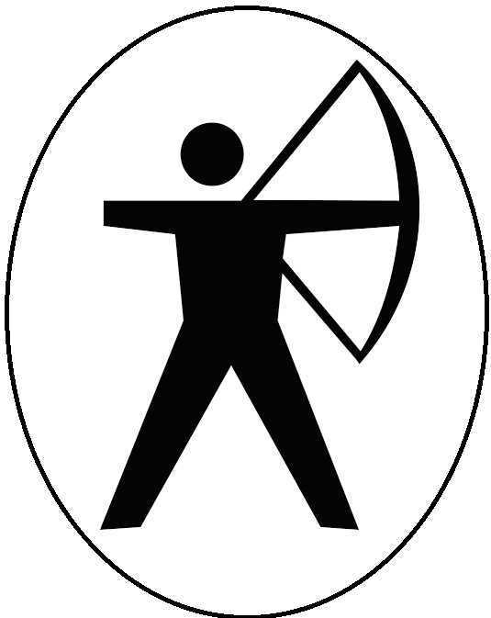

**Target platforms**

PC and Console

**Menu and General Game Usage**

There will be a main menu with the play button and quit also a game over.

**Target ESRB rating**

 **Rating Pending**

**Elevator pitch**

The arrows archer is a simple unity game where the player shoots targets to make a building collapse and to gain points also trying to reach a specific amount of points to be able to progress into the next level, if failed to gain those points, the player restarts the level.